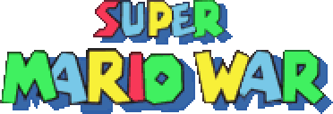
&

(UNOFFICIAL) World Editor Guide
Written by EleCyon
Original SMWar by 72dpiarmy (See Game Guide for credits)

INTRODUCTION
Welcome to the World Editor Guide!
If you want to make your own world maps for World Mode in Super Mario War/Super Cat Wars, look no further.
This is a detailed guide explaining the World Editor and how players can use maps as world stages, create paths, decorate their map, add powerups as bonuses, and more. If you’re having trouble using the World Editor, refer to this guide.
Click the World Editor in SMWar’s source folder to start the World Editor.
TABLE OF CONTENTS
INTRODUCTION
TABLE OF CONTENTS (YOU ARE HERE)
SECTION 01 – Making a New World
SECTION 02 – World Editor Controls
SECTION 03 – Terrain & Paths
SUBSECTION 03.1 – Land
SUBSECTION 03.2 – Paths & Connections
SUBSECTION 03.3 – Decorations
SUBSECTION 03.4 – Animated Tiles
SUBSECTION 03.5 – Warps
SECTION 04 – Start Points, Stages, & Interactive Content
SUBSECTION 04.1 – Stages
SUBSECTION 04.2 – Vehicles
SUBSECTION 04.3 – World Items, Doors, & Bridges
SECTION 05 – Music
SECTION 06 – Saving and Managing Worlds
SECTION 07 – Playing your World
THANK YOU FOR READING! (Conclusion)
SECTION 01 – Making a New World
When opening up the World Editor, you’ll be greeted with an example world. Press N to create a new world. Type in the name of your new world and press Enter. (Don’t worry if it goes off the box!)
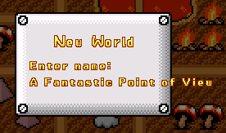
I know, this name sounds very cheesy…
In the next few screens, the game will ask for the height and width of your new world, measured in tiles. You may change this later in your new world by pressing K.
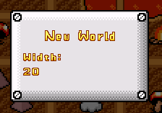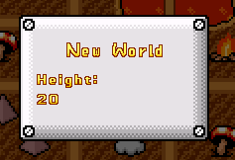
After you confirm the world size, you’ll jump straight to your empty world! Check it out below:
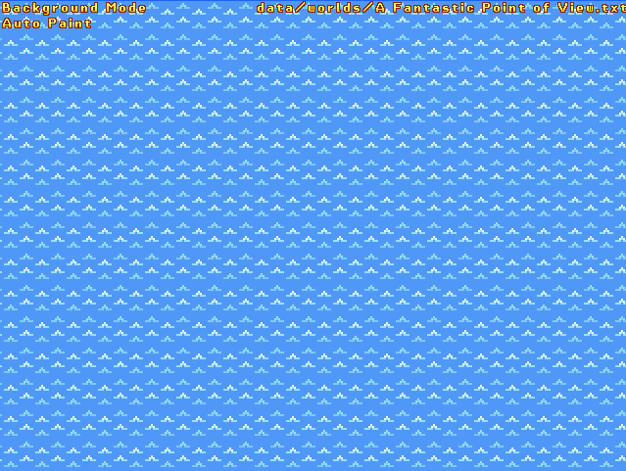
In the beginning, there was water, and ONLY water. NO MORE ANYTHING.
Your new world is saved as a text file in the worlds folder (SMWar/worlds, or SMWar/data/worlds for SMWar 2.0). Do not modify the text file at all costs, as you’ll have to do the rest in the world editor.
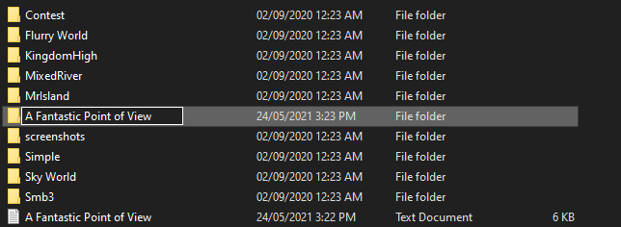
Additionally, if you want maps exclusive to your world, make an additional folder in your worlds folder with the same name as your world, for safekeeping. Maps stored inside the game are recognized by the World Editor from the Map and World folders, even subfolders inside the World folder!
NOTE: A copy of your world may appear every time you create a new map and save it, this is known as “ZZworldeditor.txt”. This serves as an automatic backup in the case of an event such as an editor crash. Note it may be overwritten every time you save a world, so be careful. Deleting this file is completely harmless!
SECTION 02 – World Editor Controls
Press F1 to bring up Help mode. This will display all the hotkeys for the World Editor, which you can see here:
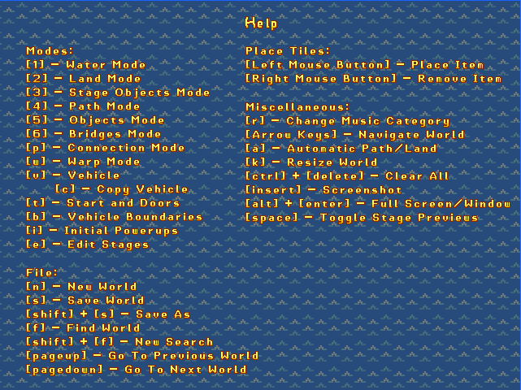
SECTION 03 – Terrain & Paths
The most important part of making a world is its terrain. This refers to the land, water, paths, connections, decorations, and warps that compose the entire world.
Important hotkey: You’ll need to press A to enable Auto-Paint Mode, if not enabled yet. This will automatically build the terrain’s edges as you draw your land, just like in Super Mario Maker. It also works with paths and connections!
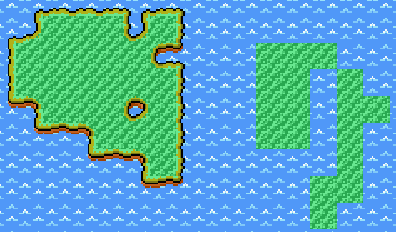
Here’s a comparison between land built in Auto-Paint Mode and land built without Auto-Paint Mode.
SUBSECTION 03.1 – Land
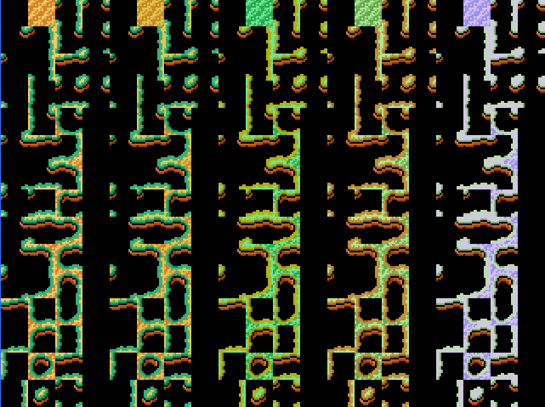
Press [2] to open Land Mode. This will bring up a tileset menu containing all the land tilesets. In Auto-Paint Mode, click the land’s centerpiece (located on top) to draw land with edges.
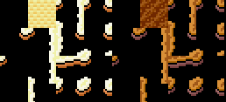
Press [2] again to open up a second page for land. In SMWar, this will bring up the tiles for World-e (Super Mario Advance 4) and World 8 (Bowser’s Castle).
Just like in the Level Editor, you can click the left mouse button to place land, and click the right mouse button to delete land.
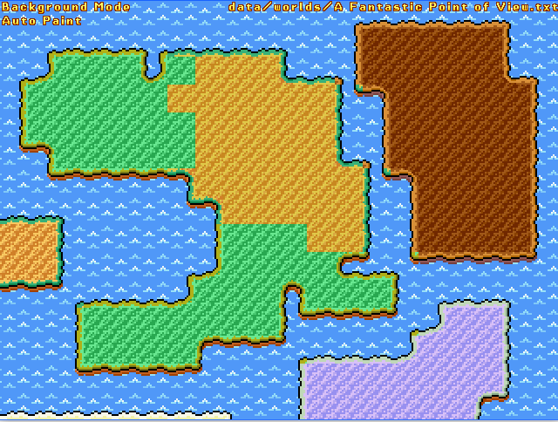
Here’s some completed terrain made using the Land Mode. You can tweak it however you like!
SUBSECTION 03.2 – Paths & Connections
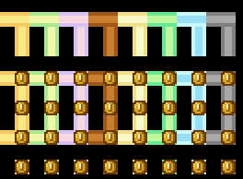
Press 4 to bring up Paths mode. This will allow you to draw the various world paths that the players must traverse to reach the end of the world. Remember: use the Auto-Paint feature to make drawing of paths easier.
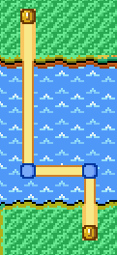
Notably, like in the original SMB3, paths take on a different appearance when they are placed into the water. Paths are not restricted to land only, so keep that in mind!
Initially, paths do not have any connections at first. What are connections?

These are connections, or Path Sprites. Connections are invisible objects that the players can walk on across the world map. To draw path conections, click on the path sprites and place them on the map.
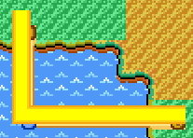
The visible paths shown on the map are now recognized by the player and can be walked on. If these Path Sprites aren’t placed, the player is unable to walk on the path, and acts as a barrier.
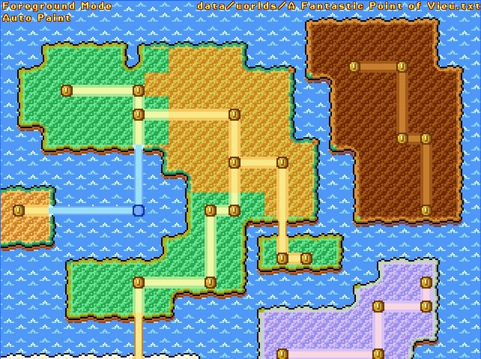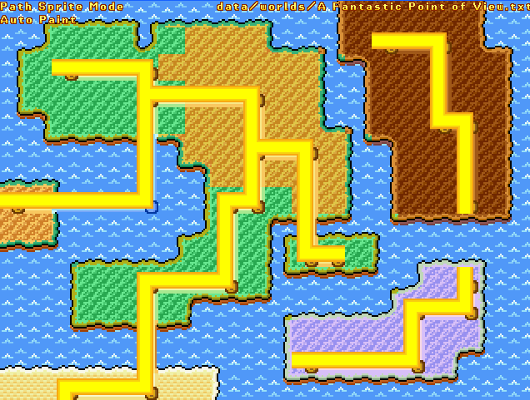
Now that we’ve placed the needed paths and connections, let’s add decorations!
SUBSECTION 03.3 – Decorations
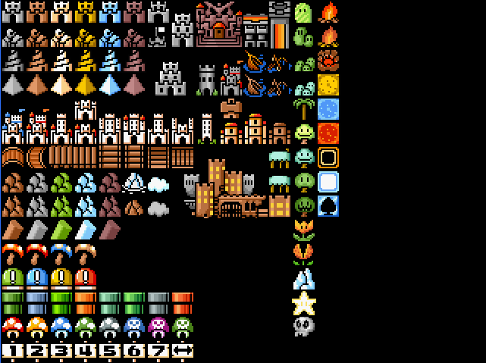
Press 5 to bring up Objects Mode, which allows you to place castles, pipes, Toad Houses/shops, and other decorations on the map. This mode is not affected by Auto-Paint, and players can left-click to place the selected item and right-click to delete decorations.
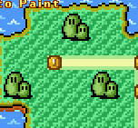
Notably, all objects on the last two columns are animated tiles, in a similar premise to Animated Tile Mode from the level editor. These tiles are animated in four frames in-game.
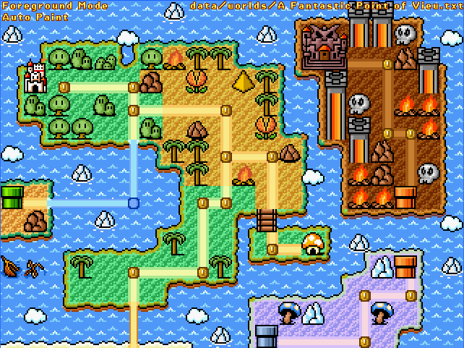
Here’s the completed decoration! Now your world map looks a lot nicer now.
SUBSECTION 03.4 – Water

A minor decoration you can modify is the water, which has low draw priority and is drawn over by land, objects, and paths. You cannot actually remove water, but you can replace it with brighter water (as seen in SMA4’s World-e) or lava (as seen in Bowser’s Castle).
You can left-click to replace water with something else, and right-click to revert to regular water. An example of water being modified into lava can be seen here:
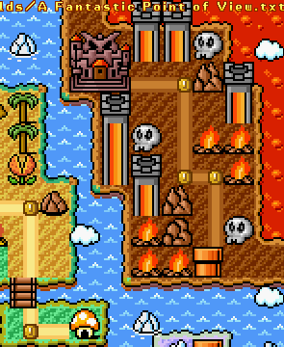
SUBSECTION 03.5 – Warps
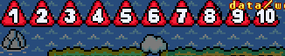
Similar to the warp tiles in maps, you can also place warps around worlds to help you traverse across the world at greater distances. Usually, warps are represented by Warp Pipes in most world maps, but you can place warps anywhere, as long as they are on the same tile that a Connection is placed on, so the player can walk over to it and use it.
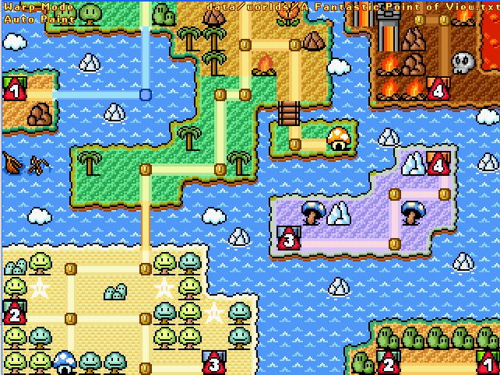
Notably, warps are much more limited in this mode: there are 10 Warp IDs, but each of them has a pair of warps in the same ID: an entry point and an exit point. You cannot create more than 2 warps on the same ID, as random exits are not permitted in World Mode.
Warps can be used indefinitely by the player, keep that in mind.
SECTION 04 – Start Points, Stages, & Interactive Content
Your new world cannot be played unless a starting point is added to the stage. This tile is represented by START in SMWar (just like in SMB3 world maps), or Alex’s Neko House in SCW.
Press [T] to bring up Start & Doors.

Click the START icon/Neko House to add it to the world and make it the player’s starting point. Regardless of color, the icon works just the same. (the blue coloration is featured in SMA4’s World-e, if you want facts)
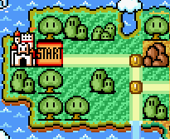
SUBSECTION 04.1 – Stages
Stages are a core part of the world map. These are represented by Stage Objects in the world, which are numbered from 1-99 or have a skull icon, and come in four colors.
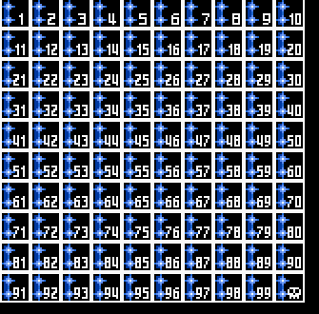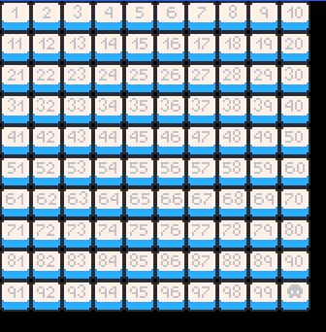
Press [3] to bring up Stage Objects Menu. You can select other colors by pressing the numbered keys 1-4. 1 is for Green, 2 is for Blue, 3 is for Yellow, 4 is for Red.
Place these stage objects on the map, and now you have something to represent stages!
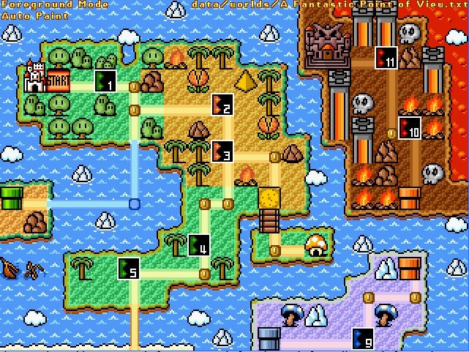
Now onto stages. Press [E] to open up Stage Mode, which will appear like this below:
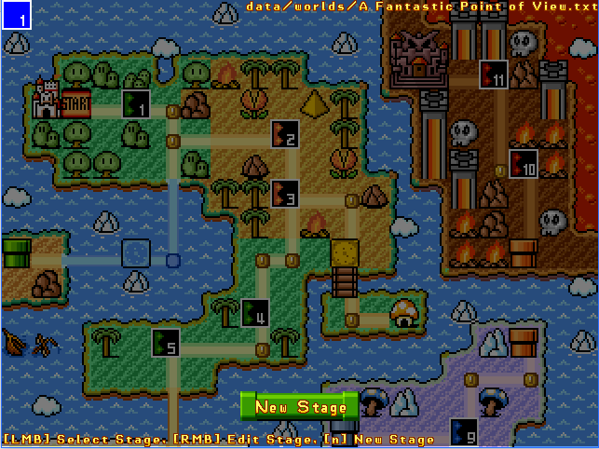
You can click the Left-Mouse Button to place stages, or press New Stage (or N on the keyboard) to create a new stage, or edit a stage by right-clicking on it. It’s also possible to check the preview for a stage by hovering your mouse cursor over the stage, as shown below: (This can be toggled by pressing the Spacebar)
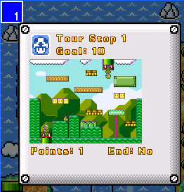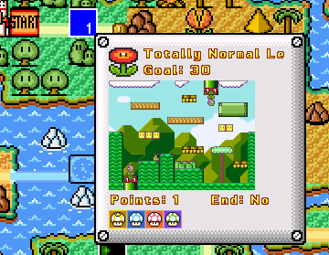
Let’s edit a stage we have just created from earlier.
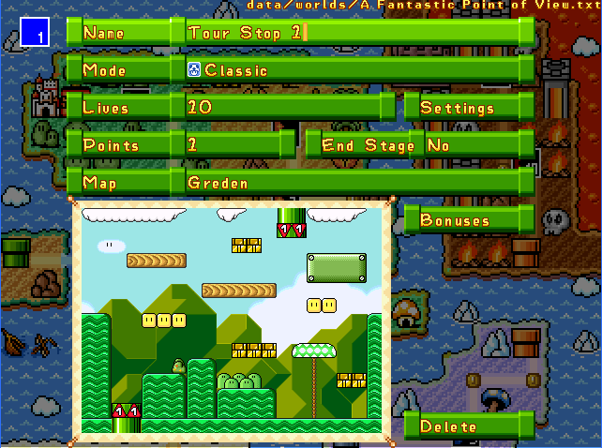
You can set the name of the stage (defaulted to “Tour Stop #”) by typing in a name. In that case, I typed the name of the stage like this:
In “Mode”, you can set the game mode to be played, as well as the basic and advanced parameters (Advanced Parameters are shown in Settings) of a game mode.
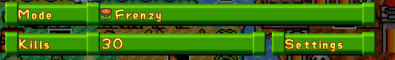
Notably, players can set the game modes to Pipe Minigame, Boss Minigame, and Boxes Minigame, which are exclusive minigames, and can be modified with a custom map and parameters unlike in Minigame Mode. See the Game Guide for more information.
Other parameters include the following:
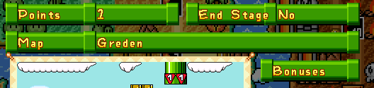
- Points is the number of points a player gains from the stage. It can be set in a value from 0-20 in intervals of 1.
- End Stage marks the stage as the final stage in a world, which when completed, concludes the current World match.
As for Bonuses, see below:
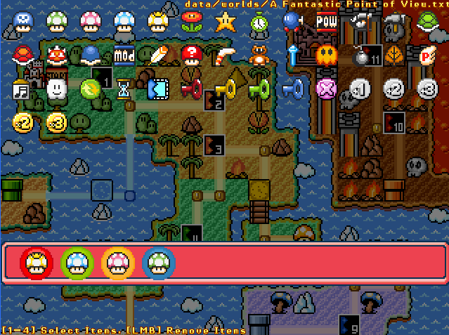
Press the numbered keys (1-4) while hovering your cursor over an item to add a bonus. If all numbered keys are used, bonus items are distributed to various players. Use the left mouse button on the bonuses slots to remove items.
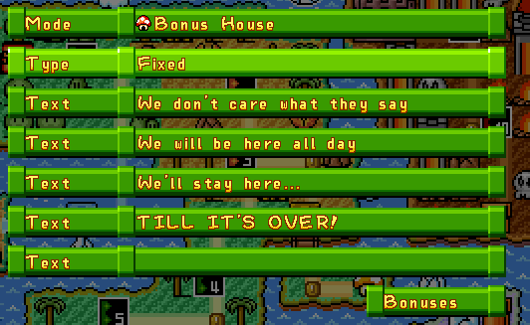
Editors can also set a stage to a Bonus House, which acts like the Toad Houses in SMB3. Players can enter a Bonus House and choose an item from any of the chests that Toad/the Shopkeeper (SCW) offers.
There are two types for a bonus house. Fixed allows the players to pick from a fixed order of items (the contents do not randomly change and are listed as such in the Bonuses list). Random randomizes the items every time the stage is played, so players may get Item 1 on a first box and Item 2 on the other.
For Bonuses, see below:
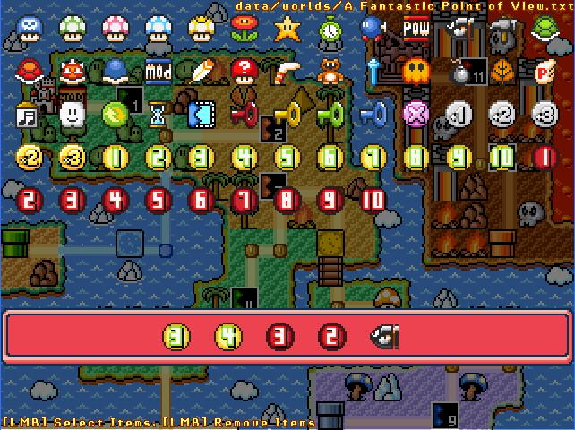
Click the items to select them and put them in the chest list (bottom). On the chest list, click items to remove them. You can choose up to five items only. The order of the items as listed in the bonuses menu will be used if the Bonus House type is set to Fixed.
SUBSECTION 4.2 – Vehicles
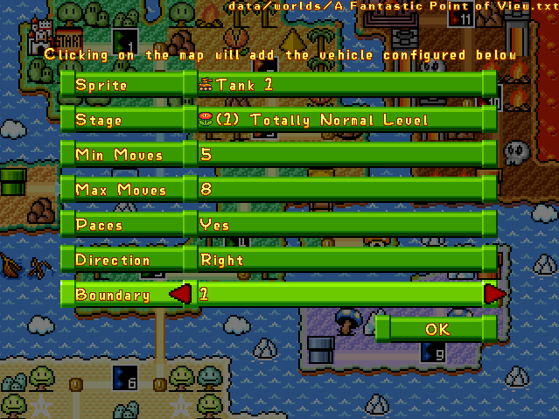
Vehicles include moving enemies & vehicles (tanks, airships, boats). They are ambush stages that move around the map every time a player completes a stage or uses an Hourglass. They automatically ambush players and start a stage immediately when walked over, unless the player uses a Music Box/Magic Flute to stop them.
As long as vehicles are placed on a connection/Path Sprite, they can start moving a set number of times in a random direction across a path when a stage is completed.
Press V to create a vehicle. Press C when hovering over a placed vehicle to copy its parameters. Parameters are as follows:
- Sprite – Sets the sprite. They are mostly SCT bosses in SCW, while there are Koopa Bros and various vehicles in SMWar.
- Stage – Sets the stage to be used. Note that stages must be created so vehicles can be placed.
- Min Moves – Minimum number of moves a vehicle can make.
- Max Moves – Maximum number of moves a vehicle can make.
- Paces – Sets whether the vehicle can pace around in one place or not.
- Direction – Sets starting direction (left and right only)
- Boundary – Sets boundary ID. See next part of this subsection for more info.
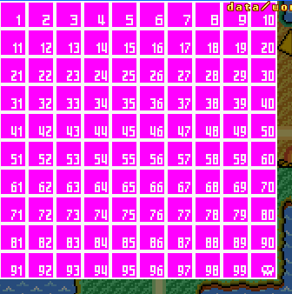
Vehicle boundaries are boundaries that prevent the vehicle from moving into unwanted places. There are 100 boundary IDs from 1-99, with 100 being represented by a skull.
A vehicle’s boundary ID must match that of the placed boundary IDs around the designated area, otherwise the vehicle will ignore boundary IDs that are different from the one assigned to the vehicle.
SUBSECTION 04.3 – World Items, Doors, & Bridges
There are various items exclusive to World Mode only. As they are covered in the Game Guide, here’s a small summary of the items’ descriptions.
Point Spheres/Extra & Minus Points

These add or subtract points from the player’s total point counter. These are exclusive to Bonus Houses/Shops.
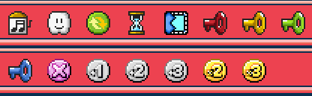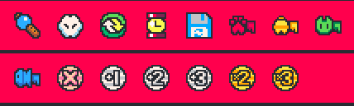
From left to right:
- Music Box/Magic Flute – Causes all vehicles to fall asleep, allowing players to pass over them. They can still play their respective stages by entering them as if were stages.
- Lakitu’s Cloud/Cloud – Allows the player to completely skip over an active stage, if any.
- Swap Badge – Swaps the current player on the map with the user of the Swap badge.
- Hourglass/Watch – Skips one turn for the stage, causing vehicles and bridges to move.
- Replay Block/Replay Disk – Allows users to play an already-completed level.
- Colored Keys – Unlocks colored doors corresponding to their color.
- X Coin – Nullifies the point value for the level.
- + Coins – Adds 1, 2, or 3 points to the level’s point value.
- X2 & X3 Coins – Multiples the level’s point value by 2 or 3.
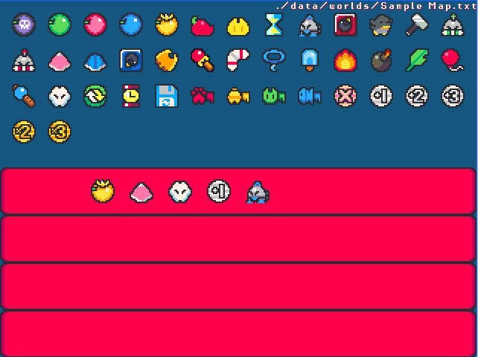
Press [I] to bring up the Initial Powerups menu, where you can give all four players eight different items. Row 1 is for Player 1’s items, Row 2 is for Player 2’s items, and so on.
The starting items can contain powerups, world items like the Swap badge and the Replay Block/Disk, colored keys, and Score Coins.
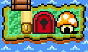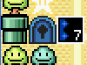
Some paths are locked behind colored doors. They can be placed by pressing [T] to open up the Start & Door Menu. If a player stands in front of a colored door and uses a colored key that matches the door, the door will open and the rest of the path will be open for the player to explore. In these images, for example, a red key and a blue key are needed to open the Red Door and Blue Door, respectively.

Drawbridges can be placed on the player’s path. They can be placed by pressing [6] to bring up the Drawbridge menu, otherwise known as Bridges Mode. The state of a drawbridge depends if a player has completed a stage or has completed a turn using the Hourglass/Watch. Open drawbridges do not permit entry for the player, while closed drawbridges can be passed through.
SECTION 05 – Music
To change the music category, press R. Each music category holds only one song per category.
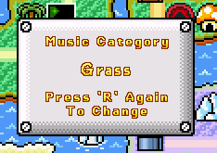
Press R again to change. There are nine music categories: Grass, Desert, Water, Giant, Sky, Ice, Pipe, Dark, and Space. The first eight categories correspond to the eight worlds in SMB3, while Space is associated with the Star World in SMW.
In Super Cat Wars, the associated songs are different. Most song titles are taken from the Neutronized Bandcamp where applicable:
- Grass – Overworld Map (Super Cat Tales)
- Desert – Ramal Town (Super Cat Tales 2)
- Water – Main Menu (Picnic Penguin)
- Giant – Cutscene (Slime Pizza)
- Sky – Kaze Towers (Super Cat Tales 2)
- Ice – Story/Ending (Drop Wizard/Drop Wizard Tower)
- Pipe – Equipping Items (Yokai Dungeon)
- Dark – Lord Iridium (Super Cat Tales 2)
- Space – Save Room (Slime Pizza)
SECTION 06 – Saving & Managing Worlds
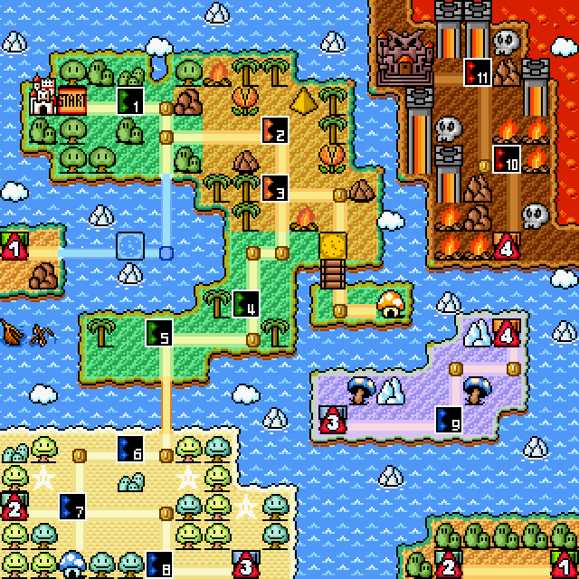
This world is now 100% complete! Feel free to take a screenshot by pressing INSERT. Screenshots are saved in the screenshots subfolder of a world.
Worlds are saved in SMWar/worlds, or SMWar/data/worlds for SMWar 2.0 and SCW.
To save a world, press S. Press Shift + S to use Save As, to save a world in a different name but same layout. Note that you’ll have to copy over the exclusive maps when doing this.
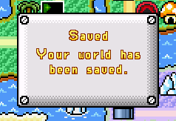
As shown in the Level Editor Guide, you can also press F to find and search worlds using the search function. For example, searching Block World will also bring up a world named Block World.
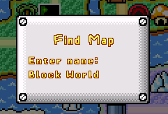
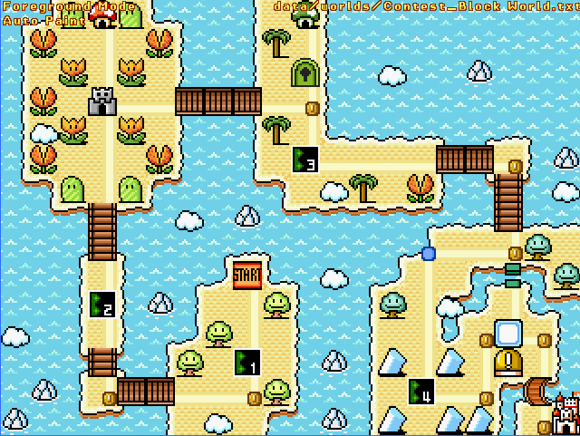
You can then press F to cycle through worlds that match the search keywords. Press Shift + F to start a new search.
You can also scroll through worlds in alphabetical order using PgUp and PgDown.
Also, if you feel like bringing in a little bit of destruction, press CTRL+DEL to clear all tiles and data on a world, and start over. This works like the Reset Rocket from Super Mario Maker 2, but NOTE THAT SAVING AN EMPTY WORLD OVER ANY COMPLETE WORLD WILL RESULT IN ALL DATA FOR THAT MAP BEING LOST! So, use with caution.
SECTION 07 – Playing Your World
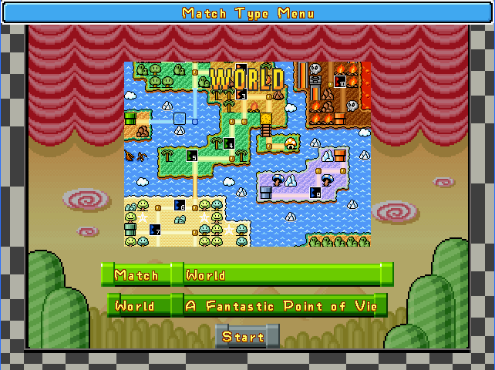
To play your world in-game, go to Match Type Menu, set the match to World, and press Start.
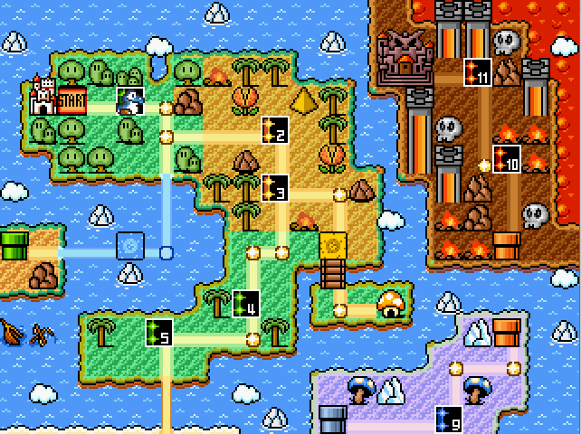
There! You can now play your world in World Mode! To complete your world, reach the final stage at the end and complete it to complete a World match in this world.
You may share this world with your friends, and if it has any exclusive maps, you may want to bundle it with the world in a ZIP file.
THANK YOU FOR READING
Thank you for reading the level editor guide! We, from 72dpiarmy, hope you can enjoy creating maps at your own pace.
For game documentation, please see “SCW SMWar Base Game Guide.docx”.
For Level Editor documentation, please see “SCW SMWar Level Editor Guide.docx”.
For online play documentation, please see “SCW SMWar Online Guide.docx”.

